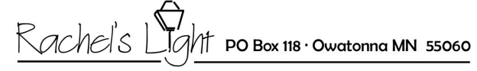

Authorization Agreement for Automatic Withdrawals

I, ___________________________________,hereby authorize Rachel’s Light, to initiate debit entries from my account as indicated below:
Amount per month $________________ Monthly/One time
Checking/Savings Option (Circle one)
Bank Name:________________________
Account No:________________________ Routing Number:____________________________

Attach voided check here:

Credit Card Option
Credit Card type:___________________ Number:_______________________Expiration:___/____/____ Security Code:_______
Name as it appears on the card:______________________________________________
Billing address:____________________________________________________________
City:____________________ Zip:_________
Signature:_____________________________________________ Date:____/____/____

